Machine Learning and Data Analytics
(Unit 1 & Unit 2)

- Differentiate between simple linear regression and multiple linear regression with suitable examples.
Basis | Simple Linear Regression | Multiple Linear Regression
Definition | Predicts the dependent variable using one independent variable. | Predicts the dependent variable using two or more independent variables.
Equation | ( Y = b_0 + b_1X + \epsilon ) | ( Y = b_0 + b_1X_1 + b_2X_2 + ... + b_nX_n + \epsilon )
Number of Independent Variables | Only one | Two or more
Relationship Type | Examines a simple linear relationship between X and Y. | Examines a multivariate linear relationship between Y and several Xs.
Visualization | Represented by a straight line on a 2D graph. | Represented by a plane or hyperplane in multidimensional space.
Computation Complexity | Simple and easy to compute. | More complex due to multiple predictors.
Interpretation | Change in Y due to one X. | Change in Y due to each X, keeping others constant.
Slope forumula | M=(n.Σ(xy)-ΣxΣy)/  n.Σ(x^2) – (Σ (x))^2 | b=(X′X)−1X′Y
Use Case Example | Predicting salary based on experience. | Predicting salary based on experience, education, and age.

- What is the role of the cost function in linear regression? Why is Mean Squared Error (MSE) commonly used?
- Measures prediction error.
- MSE = (1/n) Σ(yi - ŷi)²; preferred for penalizing large errors.

- Explain the problem of overfitting and underfitting in regression models. How can regularization techniques (L1 & L2) help to overcome overfitting? Illustrate with examples.

Aspect | Overfitting | Underfitting
Definition | Model fits training data too well, capturing noise and random fluctuations. | Model is too simple, failing to capture the underlying pattern.
Cause | Too many features, complex model, or insufficient regularization. | Too few features, overly simple model, or too strong regularization.
Effect | High accuracy on training data, poor performance on test data. | Poor accuracy on both training and test data.
Graph Representation | Curves tightly follow data points (wiggly). | Straight line missing important trends.

How Regularization Helps (L1 & L2)
Regularization adds a penalty term to the loss function to prevent large coefficients and reduce model complexity.

1️⃣ L1 Regularization (Lasso Regression)
- Adds the sum of absolute values of coefficients as a penalty:
$$\text{Loss}=\text{SSE}+λ∑∣w_{i}∣$$
- Effect: Shrinks some coefficients exactly to zero, performing feature selection.
- Focuses on sparsity like text classification
- Use Case Example:
If predicting house price with 10 variables, L1 may remove irrelevant ones (e.g., “wall color”), keeping only useful ones like area and locations

2️⃣ L2 Regularization (Ridge Regression)
- Adds the sum of squares of coefficients as a penalty:
$$\text{Loss}=\text{SSE}+λ∑w_{i}^{2}$$
- Effect: Shrinks coefficients closer to zero but not exactly zero, reducing overfitting by smoothing the model.
- Focuses on multi collinearity when features are dependent on each other
- Use Case Example:
In predicting sales, if two features (TV ads and Radio ads) are highly correlated, L2 helps distribute their influence evenly, avoiding instability.

- A retail company wants to forecast its monthly sales revenue using regression analysis. The independent variables include advertising spend, price discount percentage, and number of promotional campaigns.
o Formulate how you would set up a multiple linear regression model for this case.
Sales = b0 + b1*Ad + b2*Discount + b3*Campaigns.
  - Which factors could cause bias and variance in your model?

Concept | Meaning | Example in this case
Bias | Error due to wrong or oversimplified assumptions. Model doesn’t capture reality properly. | ❌ Missing variables like “seasonal demand” or “competitor pricing” → sales predictions biased.
Variance | Error due to too much sensitivity to training data (model overfits). | ❌ Too many predictors or interaction terms (Ad × Discount × Campaigns, etc.) make model unstable and vary with new data.

  - How would you evaluate the model’s accuracy?
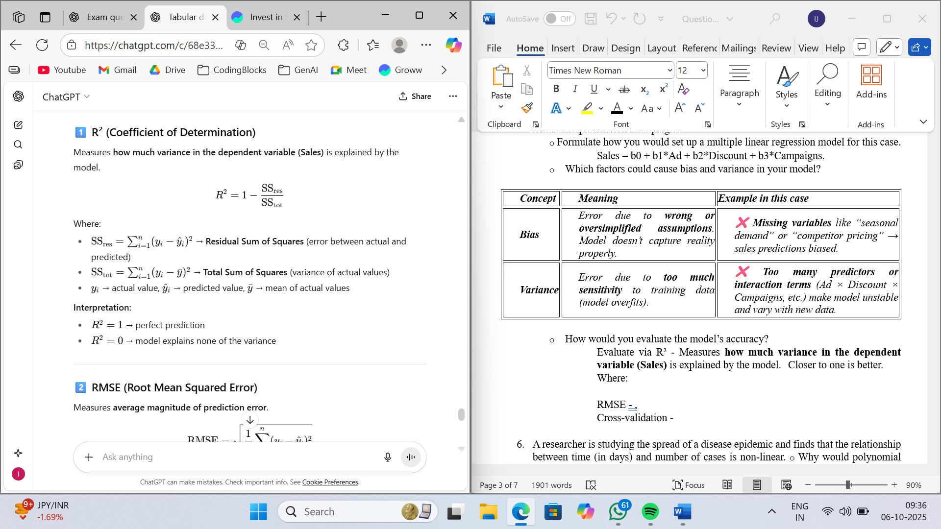
Evaluate via R² - Measures how much variance in the dependent variable (Sales) is explained by the model.

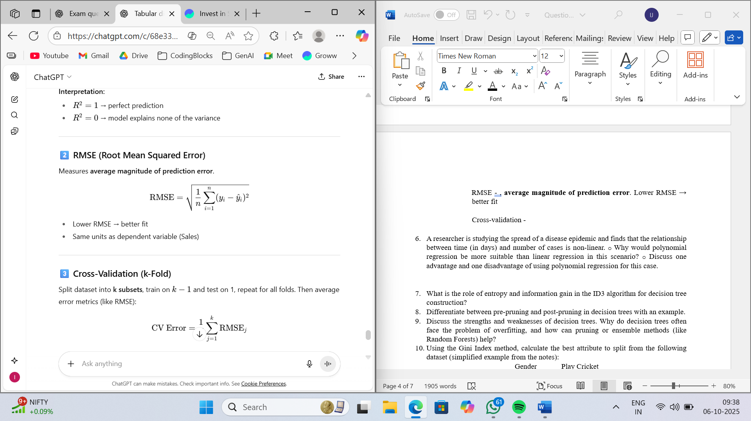
RMSE - average magnitude of prediction error. Lower RMSE → better fit

Cross-validation (k-fold)- Split dataset into k subsets, train on $k-1$and test on 1, repeat for all folds. Then average error metrics (like RMSE):
$$\text{CV Error}=\frac{1}{k}\sum_{j=1}^{k}{}{\text{RMSE}}_{j}$$
Helps detect overfitting and Ensures model generalizes to new data

- A researcher is studying the spread of a disease epidemic and finds that the relationship between time (in days) and number of cases is non-linear.
o Why would polynomial regression be more suitable than linear regression in this scenario?
Ans->Fits curved patterns better than linear.
o Discuss one advantage and one disadvantage of using polynomial regression for this case.
Ans-> Adv: Captures nonlinearity. Disadv: Overfits easily.
- A low-degree polynomial (like quadratic) may capture the trend without overfitting.
- A high-degree polynomial may follow every data point → poor prediction for future days.

- What is the role of entropy and information gain in the ID3 algorithm for decision tree construction?
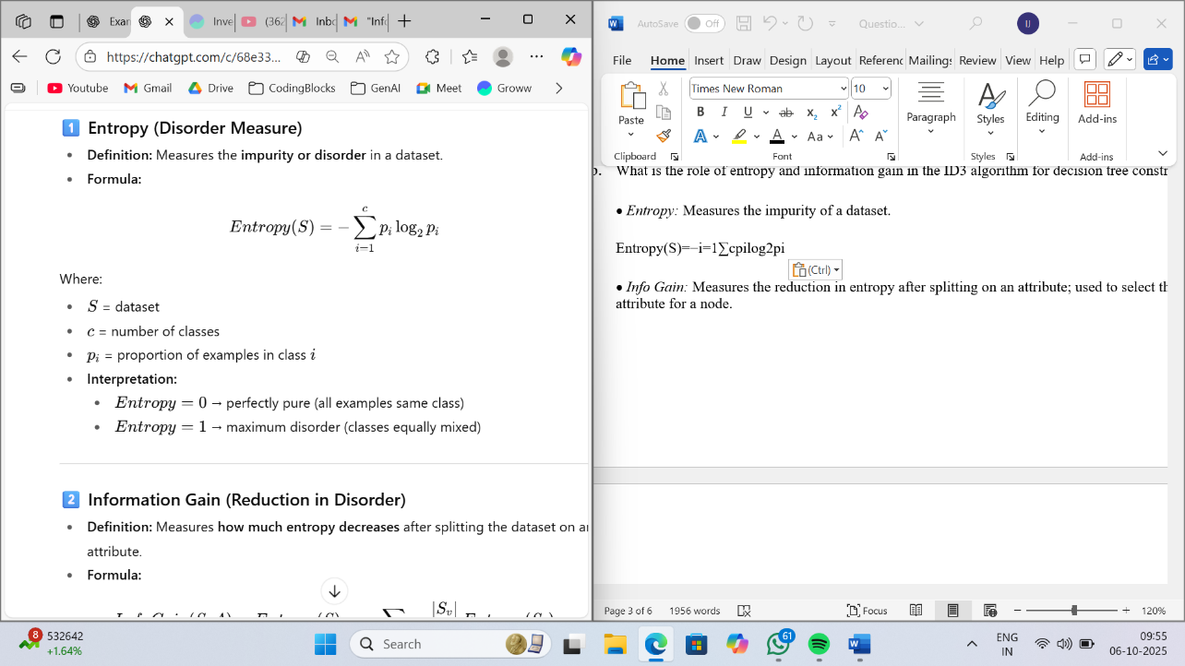
• Entropy: Measures the impurity of a dataset.

• Info Gain: Measures the reduction in entropy after splitting on an attribute; used to select the best attribute for a node.

- Differentiate between pre-pruning and post-pruning in decision trees with an example.

Aspect | Pre-Pruning (Early Stopping) | Post-Pruning (Prune after full growth)
Definition | Stop tree growth before it perfectly fits training data. | Grow the tree fully, then remove branches that do not improve generalization.
When Applied | During tree construction. | After the tree is fully built.
Goal | Prevent overfitting early. | Correct overfitting after full growth.
Complexity | Simpler tree, smaller computation. | Requires full tree first → more computation.
Risk | May underfit if stopped too early. | Less risk of underfitting; can find optimal tree.
Example | Stop splitting a node if number of samples < 5. | Remove a branch that splits 2 samples but doesn’t improve accuracy.

- Discuss the strengths and weaknesses of decision trees. Why do decision trees often face the problem of overfitting, and how can pruning or ensemble methods (like Random Forests) help?
- ADVANTAGE -> Easy, can make a flowchart as well, handles both numerical & categorical data, non linear relationships, works without normalization or feature scaling.
- DISADVANTAGE –> Overfits, unstable, high variance, bias towards attributes with many layers. Poor outside training. Focus more on outliers and noise.
- Fix: Pruning, Random Forest: Build multiple trees on random subsets → average predictions → reduces variance, Boosting (e.g., XGBoost): Sequential trees that correct previous errors → robust model.

- Using the Gini Index method, calculate the best attribute to split from the following dataset (simplified example from the notes):
Gender | Play Cricket
Male | Yes
Male | No
Male | Yes
Female Yes
Female No

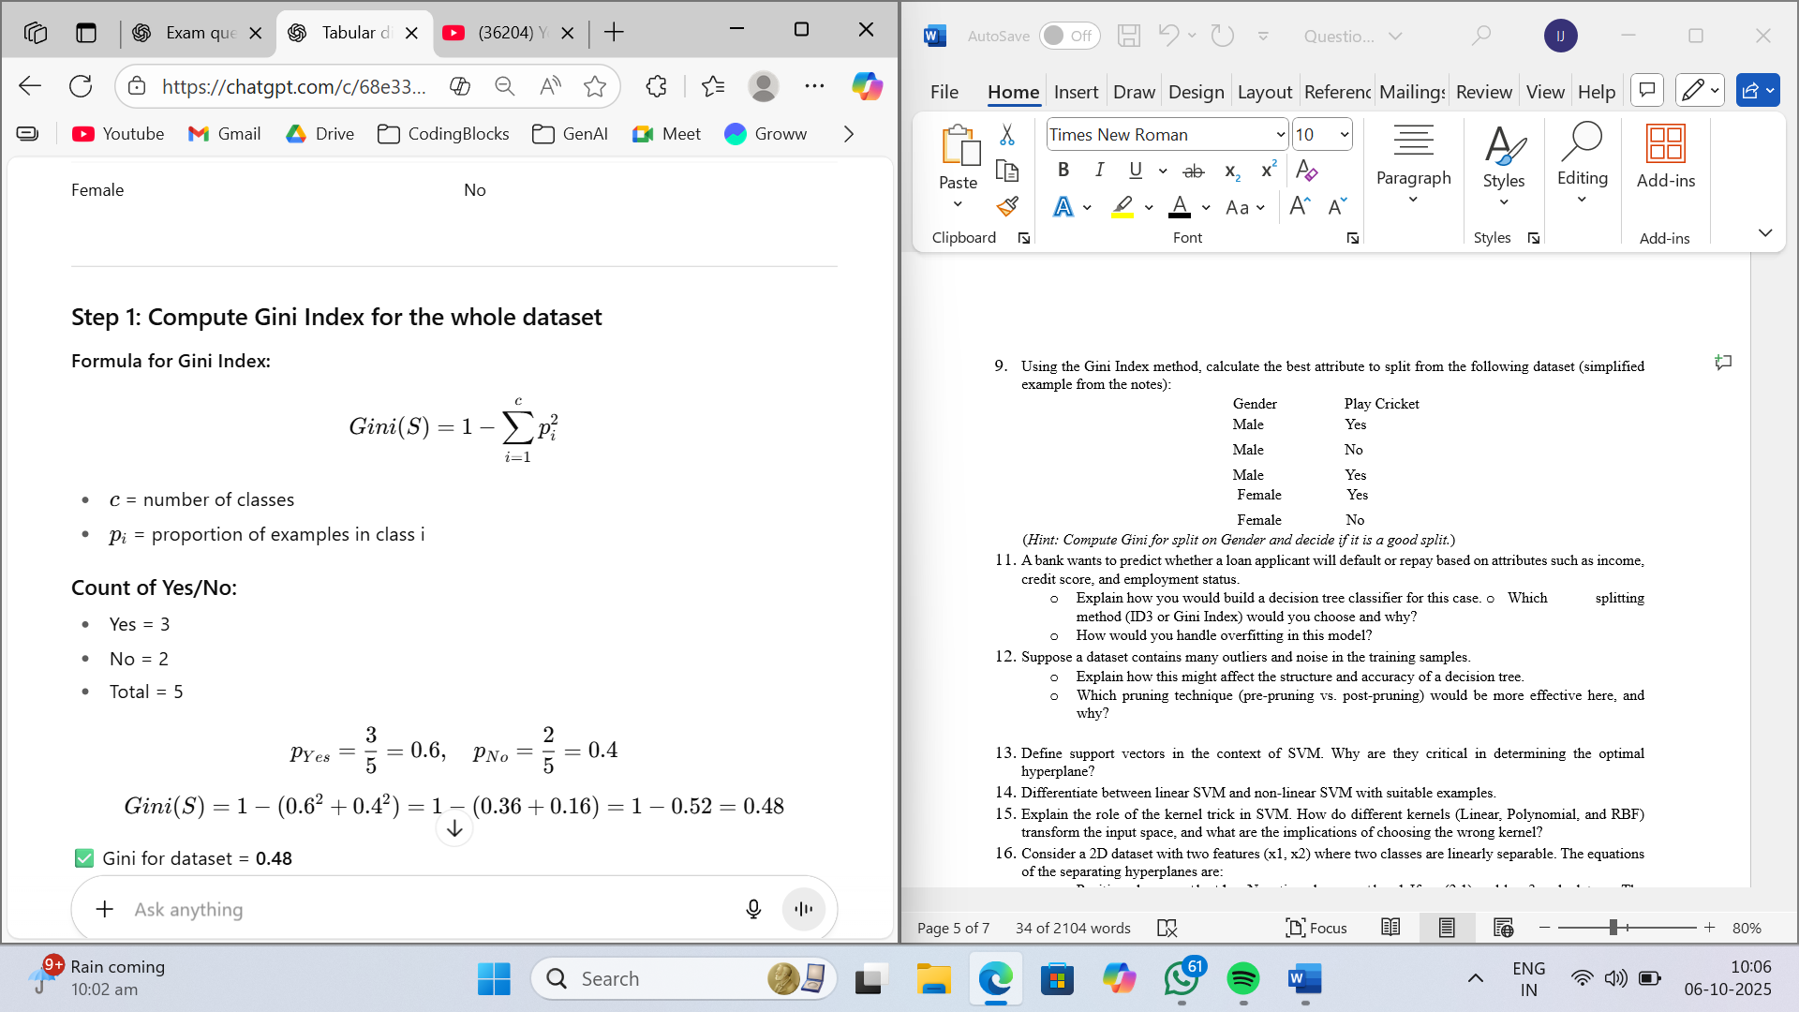
(Hint: Compute Gini for split on Gender and decide if it is a good split.)
- Yes = 3
- No = 2
- Total = 5
$$p_{Yes}=\frac{3}{5}=0.6,p_{No}=\frac{2}{5}=0.4 \\ Gini(S)=1-({0.6}^{2}+{0.4}^{2})=1-(0.36+0.16)=1-0.52=0.48$$
✅ Gini for dataset = 0.48
Compute Gini Index for splitting by Gender
Gini(Male)=1−((2/3)2+(1/3)2)=1−(4/9+1/9)=1−5/9=4/9≈0.4
Gini(Female)=1−((1/2)2+(1/2)2)=1−(0.25+0.25)=1−0.5=0.5
$$Gini_{split}=0.2664+0.2=0.4664≈0.466$$Gini Gain=Gini(S)−Ginisplit​=0.48−0.466=0.014

- Define support vectors in the context of SVM. Why are they critical in determining the optimal hyperplane?
Support vectors are the data points that lie closest to the decision boundary (hyperplane) in a Support Vector Machine (SVM).
These points “support” or define the position and orientation of the hyperplane.
Mathematically, for a linear SVM:
$$y_{i}(w⋅x_{i}+b)=1$$
where $x_{i}$are the support vectors.
Why Are Support Vectors Critical?
- The optimal hyperplane is determined only by the support vectors, not by all the points in the dataset.
- They maximize the margin between classes → SVM finds the hyperplane with the largest separation.
- Removing non-support vectors does not affect the hyperplane.
- Differentiate between linear SVM and non-linear SVM with suitable examples.

Aspect | Linear SVM | Non-Linear SVM
Definition | Finds a straight-line (or hyperplane) to separate classes. | Uses kernel functions to map data into higher dimensions to separate non-linear patterns.
Decision Boundary | Straight line (2D) / flat hyperplane(higher dimensions) | Curved or complex boundary in original space
Use Case / Example | Separating emails as Spam/Not-Spam when features are clearly separable | Classifying circular data points: e.g., points inside a circle = Class A, outside = Class B
Kernel | No kernel needed | Requires kernel function (RBF, polynomial, sigmoid)
Complexity | Simpler, faster | More complex, computationally intensive
Advantage | Efficient and easy to interpret | Can handle complex, non-linear relationships
Disadvantage | Cannot handle non-linear patterns | More prone to overfitting if not tuned

- Explain the role of the kernel trick in SVM. How do different kernels (Linear, Polynomial, and RBF) transform the input space, and what are the implications of choosing the wrong kernel?
Answer-> • Some datasets are not linearly separable in the original feature space.
Solution (Kernel Trick): Transforms data into a higher-dimensional space where a linear hyperplane can separate classes

- Linear → line
- Polynomial → curves Ex: Classifying data in an XOR pattern
- RBF (Radial Basis Function) → circles or complex boundaries (infinite dimensions) Ex;points inside or outside circle
Wrong kernel → poor accuracy.

- Consider a 2D dataset with two features (x1, x2) where two classes are linearly separable. The equations of the separating hyperplanes are:
Positive class: wx+b=+1
Negative class: wx+b=−1
If w=(2,1) and b=−3, calculate:
The equation of the optimal hyperplane.
Ans-> w = (2,1), b=-3 → Optimal plane: 2x₁ + x₂ - 3 = 0.
The margin width between the two classes.
Margin (distance between +1 and -1 hyperplanes): 2 come from distance between c1 and c2
$$\text{Margin}=\frac{2}{∥w∥}$$
- Magnitude of $w$:
$$∥w∥=\sqrt{2^{2}+1^{2}}=\sqrt{4+1}=\sqrt{5} \\ \text{Margin}=\frac{2}{\sqrt{5}}≈0.894$$
✅ Margin width:
$$\boxed{0.894\text{ units}}$$
- A company wants to build an email spam classifier using SVM.
  - Which kernel would you prefer for text classification and why?
  - How would you tune the C and gamma parameters to avoid overfitting or underfitting?
  - Discuss one advantage and one disadvantage of using SVM for this task.

- Text data is usually high-dimensional (each word = a feature).
- In high-dimensional sparse data, classes are often linearly separable.
- Linear kernel is faster and performs well compared to RBF or polynomial.
- Tuning C and Gamma
- C (Regularization Parameter):
  - Controls trade-off between margin width and misclassification.
  - High C → low bias, high variance → model fits training data closely → risk of overfitting.
  - Low C → high bias, low variance → allows some misclassification → reduces overfitting.
- Gamma (for RBF kernel, if used):
  - Controls influence of a single training point.
  - High gamma → overfitting (points influence a small region).
  - Low gamma → underfitting (points influence a large region).
For linear kernel: gamma is not used; only C is tuned using cross-validation.

- In Support Vector Regression (SVR), what is the role of the epsilon-insensitive zone? Explain how SVR differs from traditional linear regression in handling outliers and noisy data.
The epsilon-insensitive zone (or epsilon-tube) is a region around the predicted function where errors are ignored.
Points lying within ±ε of the predicted value are considered “good enough” and do not contribute to the loss function.
Minimizes error.

- Why is KNN considered a lazy learning algorithm? How does it differ from modelbased learning techniques?
No model built; computes during prediction

- List any two advantages and two disadvantages of using KNN for classification tasks.
- Simple, no training, Non-Parametric & Flexible:
- Slow, sensitive to scale/noise, Computationally Expensive, need to be feature scaled.
- Explain the effect of different values of K in the KNN algorithm. What issues can occur when K is too small or too large, and how can we decide the optimal K for a dataset?
• Small K → noise-sensitive.
• Large K → smooth but biased.
• Use cross-validation to pick K.

- Why is Naïve Bayes called “naïve”? Explain with an example.
• It assumes that all features are independent of each other given the class label.
• This assumption is “naïve” because, in real-world data, features are often correlated. Ex: Spam detection: P(Free ∩ Offer ∩ Click)

- List any two pros and two cons of the Naïve Bayes classifier.

- Fast, works on small data
- Independence assumption, poor on correlated data.

- Explain how prior probability, likelihood, and posterior probability interact in the Naïve Bayes algorithm. Use the example of predicting whether a cloudy morning leads to rain to illustrate your answer.

- Consider the following weather dataset:
- P(SunnyYes)=3/9=0.33
- P(Yes)=9/14=0.64
- P(Sunny)=5/14=0.36
Use the Naïve Bayes formula to calculate P(YesSunny). Based on the result, decide whether players are likely to play on a sunny day.

- A company wants to build an email spam filter using Naïve Bayes.
  - Which type of Naïve Bayes model (Gaussian, Multinomial, or Bernoulli) would be most appropriate, and why?
  - What problem might occur if a word appears in the test email but was not observed in the training data?
  - Suggest a solution to handle this issue.

- Suppose you are using Naïve Bayes to predict whether a person has flu based on symptoms like fever, cough, and sore throat. o Why might the independence assumption of Naïve Bayes lead to incorrect predictions in this case?
  - Despite this limitation, why is Naïve Bayes still widely used in practice?

- Define clustering. How does it differ from classification in machine learning?

- List two advantages of using clustering in real-world applications such as marketing or recommendation systems.

- Compare partitioning, hierarchical, and density-based clustering approaches. Explain with suitable examples when each is most effective.

- Consider the following 2D points:
(2,3),(3,3),(6,8),(7,9).
Apply one iteration of K-means clustering with k=2.
- Initialize centroids as C1=(2,3) and C2=(6,8).
- Assign points to the nearest cluster using Euclidean distance.
- Compute the new centroids after this iteration.

- A bank wants to segment its customers using clustering based on income and debt levels.
  - Explain how clustering can help in targeted marketing strategies.
  - Which clustering algorithm (K-means, Hierarchical, DBSCAN) would you recommend in this case and why?
  - How would you evaluate whether the clusters formed are meaningful?

- The Dunn Index and Inertia are two evaluation metrics for clustering.
  - Explain how each metric works and what it tries to optimize. o If you have compact clusters that are still very close to each other, what will happen to these two metrics?

- Define dimensionality reduction. Why is it important in machine learning?

- Differentiate between feature selection and feature extraction with one example each.

- Explain the step-by-step process of Principal Component Analysis (PCA) with mathematical justification. Why is standardization required before applying PCA?

- Consider the following two variables X and Y:
- X=[2,4,6]
- Y=[1,3,5]
  - Compute the mean of X and Y.
  - Compute the covariance between X and Y.
  - Based on your result, state whether X and Y are positively or negatively correlated.

- A company is working with a dataset containing 1,000 features for customer behavior prediction.
  - Why might applying dimensionality reduction improve both model performance and training speed? o Which method would you recommend between PCA and Random Forest Feature Importance, and why?
  - How would visualization in 2D/3D after PCA help business decision-making?

- Compare PCA, ICA, and LDA in terms of:
  - Their objective (variance, independence, or class separation) o Whether they are supervised or unsupervised o One real-world application for each

